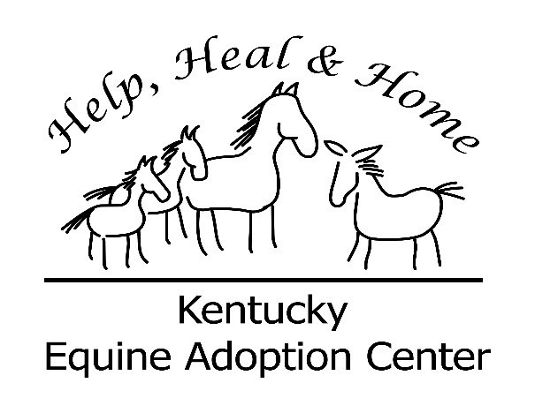

Development Director – Kentucky Equine Adoption Center

Responsibilities:

- Develop overall KyEAC fundraising strategy and prepare annual plan
- Research, write, track and manage all grant proposals and submittals – 20+ per year
- Research , identify and develop fundraising opportunities locally and nationally
- Manage all social media outreach: Website, Facebook, Twitter and Instagram
- Oversee Direct Mail program, (2/yr), track and report performance
- Solicit, develop and maintain private foundation and corporate support
- Oversee all special event fundraising – 1 large event, 2 medium size events, and multiple small events annually
- Oversee all administrative tasks related to development, including donor recognition, maintenance of online memberships such as Guidestar, etc
- Research and solicit new partnerships that will benefit the KyEAC
- Assists in planning and management of KyEAC’s Equine Growth and Communication Program (therapy) and Take the Reins Education program

Approximately 50-60% of incumbent’s time is spent travelling, locally within the central KY area, and making connections and appointments with existing and potential supporters. Work week is 40 hours and ability to work weekends and evenings at times is necessary.

Interested applicants contact: Karen Gustin, Executive Director 859-881-5849

