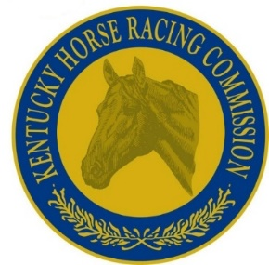

Horse Racing Veterinarian
(Full Time Interim)
with the
Kentucky Horse Racing Commission

The Kentucky Horse Racing Commission is seeking qualified applicants to fill a full time position of Interim Horse Racing Veterinarian. The interim term is up to nine months per year.
The ideal candidate must be a graduate of an accredited college or university with a Doctor of Veterinary Medicine degree. Must be licensed, or eligible to be licensed, by the Kentucky Board of Veterinary Examiners, with a minimum of two years of equine experience, preferably in a racetrack setting. Work is typically performed outdoors in horse barns and at racetracks. Attention to detail is critical. Required to maintain a valid driver’s license, and must be willing to work alternate work schedules, including weekends and holidays. Occasional overnight travel required with expenses reimbursed. Benefits include sick leave, compensatory leave, and holiday compensation.
Responsibilities include, but are not limited to, the following:
- Performs pre-race examinations to determine a horse’s fitness and soundness to race
- Administers race day Lasix, and responsible for attendant documentation and record keeping
- Performs duties on the racetrack, including paddock, ambulance and starting gate duties
- Assists in post-race exams and testing procedures with necessary record keeping
- Advises racing officials on matters pertaining to veterinary medicine
- Other duties as assigned

Interested candidates should contact:
Dr. Bruce Howard (502) 338-3730
Email: bruce.howard@ky.gov
Chief Veterinarian/Acting Equine Medical Director
Kentucky Horse Racing Commission

