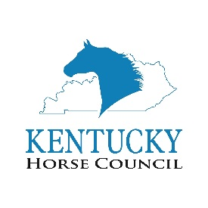
Livestock Investigation Training Sponsor Form
Level 1: Morehead State May 11-13, 2020
Level 2: WKU August 10-12, 2020
Levels | Sponsorship Benefits | Amount:
Presenting | - Recognition as Presenting Sponsor  - Opportunity to Address Attendees at Training  - Logo Placement on the Kentucky Horse Council LIT Website Page*  - Logo Placement on the Front of the Training Manuals*  - Press Release Inclusion  - Literature Placement on a Table at the Trainings | $2,500
Gold | - Logo Placement on the Kentucky Horse Council LIT Website Page*  - Logo Placement on the Front of the Training Manuals*  - Press Release Inclusion  - Literature Placement on a Table at the Trainings | $1,500
Silver | - Logo Placement on the Kentucky Horse Council LIT Website Page*  - Logo Placement on the Back of the Training Manuals*  - Press Release Inclusion | $1,000
Lunch | - Recognition as the Lunch Sponsor on One Day of the Training  - Name Recognition on the Kentucky Horse Council LIT Website Page  - Name Recognition on the Back of the Training Manuals | $500
Custom | - Benefits Can Be Negotiated | $_____________

* Please email your print quality logo to lauren@kentuckyhorse.org as soon as possible.

To complete your KHC Livestock Investigation Training Sponsorship, please complete this form and send it with payment to:
Kentucky Horse Council, Inc.
4037 Ironworks Parkway, Suite 120
Lexington, KY 40511
Please Complete the Following and Return by March 2, 2020 for Optimal Advertising Opportunity:
Organization Name:
Contact Name: | Address:
City: | State: | Zip Code:
Phone: | Email:
Website:

